20.41: a)
For the heat pump 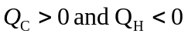
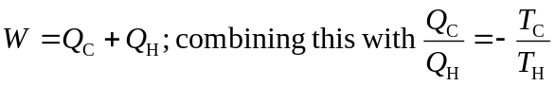 gives 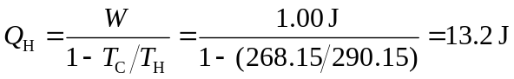

b) Electrical energy is converted directly into heat, so an electrical energy input of 13.2 J would be required.

c) From part (a), 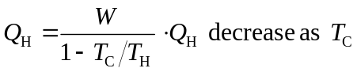decreases.

The heat pump is less efficient as the temperature difference through which the heat has to be “pumped” increases. In an engine, heat flows from 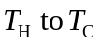 and work is extracted. The engine is more efficient the larger the temperature difference through which the heat flows.

